The Brandizzi laboratory started at the PRL in 2006. Research in our laboratory focuses on the investigation of the mechanisms for establishment and maintenance of organelles of the secretory pathway in growth and stress in plants.

We couple functional genomics and advanced live-cell imaging to investigate organelle biology and the role of endomembranes in the biosynthesis of biofuels precursors, photosynthesis, stress biology on Earth and in space.

**BIOFUELS Project:**

Hemicellulose is a natural sink of carbon that can be used in biofermentors for biofuel production. To better understand how hemicellulose is produced and deposited, we have used proteomics and isolated the proteome of Golgi-enriched fractions in developing cotton fibers. This approach has led to the identification of numerous proteins with unknown function that we are now functionally characterizing in our lab. We expect to translate the information that we are gathering with our approach into crops and select plants with high hemicellulose content.



Fig 1: Cross section of Flax stained with Safranin O and Fast Green. Flax stem section, peal contains phloem rich fibers leaving xylem core intact.

**SPACE Biology Project:**

Successful plant growth in closed-loop life support conditions is a difficult challenge for the realization of long-term habitation of spacecraft and other extraterrestrial environments. In such environments, plants can undergo stress induced by a number of factors including changes in gravity, radiation, vibration, limited exchange of gases and suboptimal growth conditions (temperature, light, nutrients). These sources of stress are often associated with reprogramming of gene expression and can cause limited plant growth, development and yield. To facilitate plant life in space, it is crucial to acquire a better understanding of the genetic changes that enable plant cells to respond to spaceflight stress. To do so, one goal of our work is to define the underlying mechanisms of plant adaptation to spaceflight environment at a transcriptional level.  To contribute further to the successful realization of habitation in space, we also aim to develop plants that can function as bioindicators of stress during in-flight situations. The availability of real-time stress bioindicators will provide scientists and astronauts with direct readouts of stress in the space environment. The results gathered in our research will contribute to NASA’s strategic plans for the realization of long-term habitation of space and planetary surfaces. Because of the conservation of stress sensing and response mechanisms across multicellular organisms, we expect that our results will also have important implications for the general knowledge of stress and in the design of solutions for space stress management in multicellular organisms, including humans.

**ENDOMEMBRANES and PHOTOSYNTHESIS Project:**

Photosynthesis is a self-assembling, self-replicating solar energy system, and the cell as a whole cooperates to build and maintain it. To ensure a balance of energetic inputs and outputs with respect to the cell’s variable physiological demands, the function, physiology and number of chloroplasts are coordinated with other cellular organelles. Therefore, chloroplasts do not function as independent energy-generating units but respond to cellular clues, which in turn modulate their activities. Little is known about how the functions of different organelles are coordinated to build and sustain efficient energy capture under dynamic environmental conditions. Our long-term goal is to discover the mechanisms for generation and maintenance of chloroplast interactions with other organelles. In our lab we are currently investigating the mechanisms that enable the functional and physical communication of chloroplasts with the plant ER about which virtually nothing is known. Our priority is to determine the factors that enable ER-chloroplast communication to sustain photosynthesis in fluctuating growth conditions.

**STRESS BIOLOGY Project:**

Adverse environmental conditions as well as physiological situations requiring enhanced secretory protein synthesis can cause an imbalance between demand and capacity of protein synthesis at the endoplasmic reticulum (ER). The ER can sense stress and restore homeostasis by invoking a protective signaling pathway known as the unfolded protein response (UPR). To initiate UPR, yeast largely relies on a linear arm based on the action of a conserved sensor, Ire1p. During the course of evolution, the suite of UPR arms harnessed additional sensors to accommodate more specific responses in a multicellular context. A major challenge in UPR studies is now to understand the biological role of the various UPR arms in intact organisms to define how the UPR signaling network functions to direct diverse cell-fate decisions in development and response to biotic and abiotic stress. In our lab we take advantage of the conservation of plant and metazoan UPR and the availability of powerful genomics and molecular tools in the model plant *Arabidopsis thaliana* to address these questions.

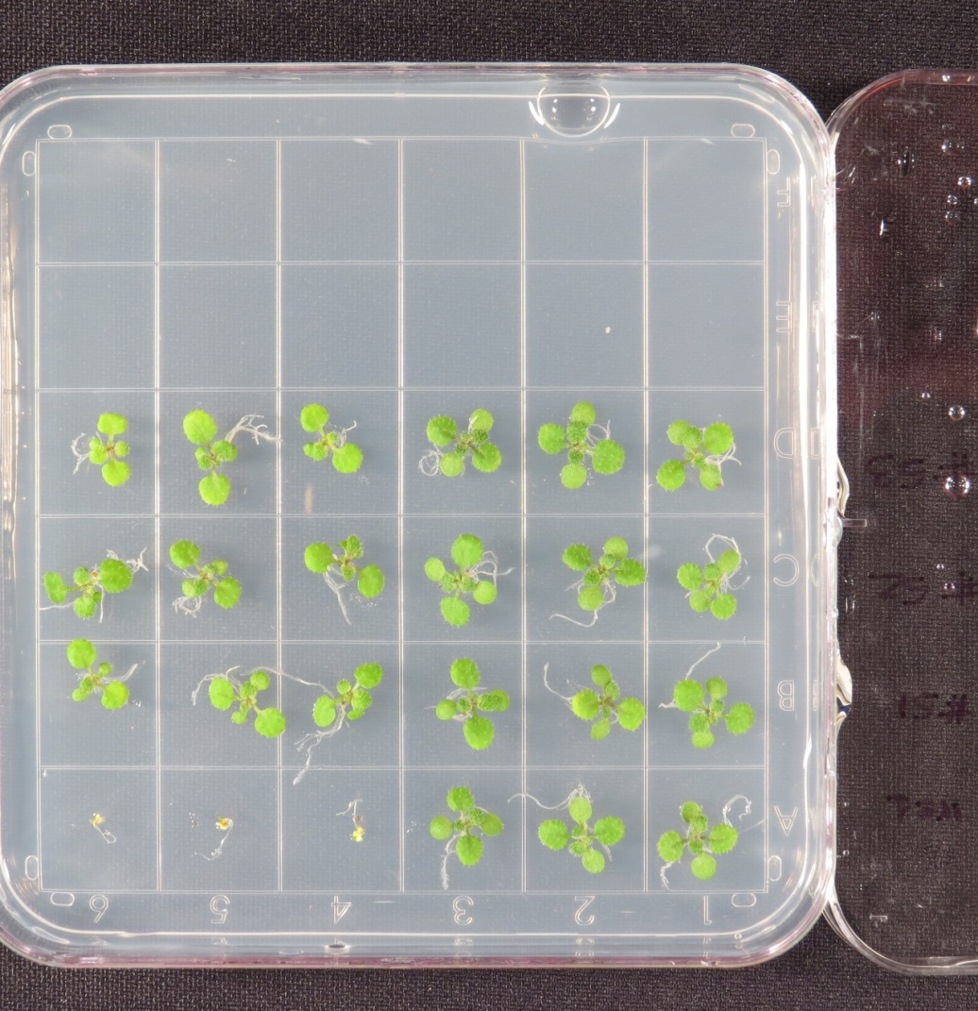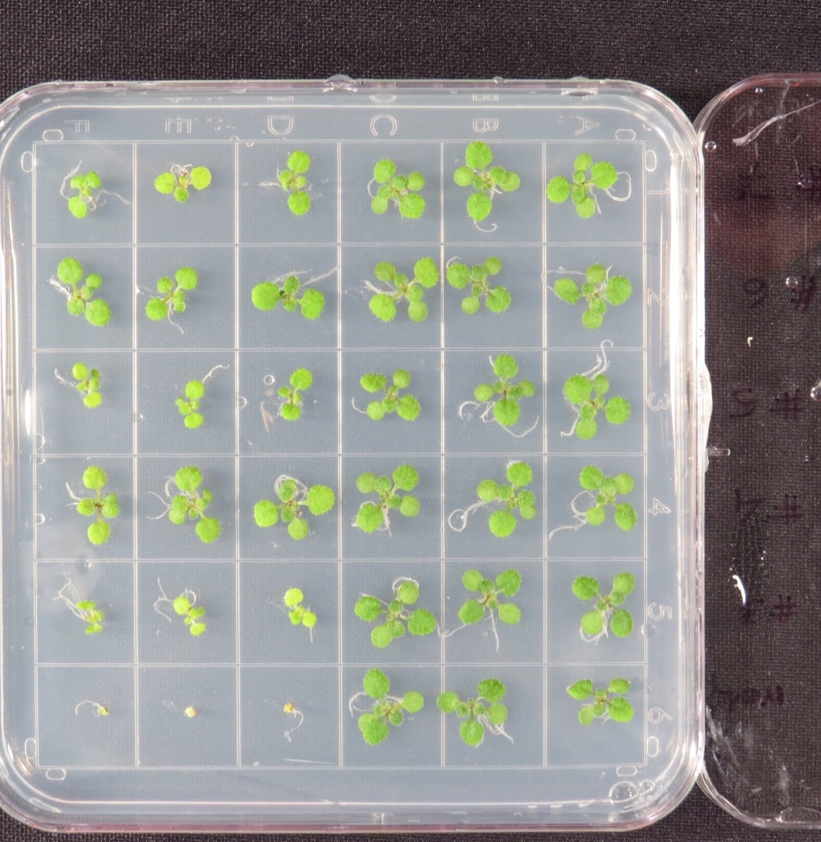

Unstressed condition

Stressed condition

Sensitivity

to stress

Fig 2: Arabidopsis seedlings exposed to treatment inducting stress reflect sensitivity to stress.

**ORGANELLE BIOLOGY Project:**

A central question in eukaryotic cell biology is how the identity of organelles is established and maintained. The endoplasmic reticulum (ER) is an essential organelle of the secretory pathway for the production of a wide variety of the cell’s building blocks, as well as for the control of essential stress and hormonal signaling pathways. To achieve maximum efficiency, the ER assumes a unique architecture characterized by a network of interconnected membrane tubules and sheets to form closed polygons. Part of the cortical ER is physically linked directly underneath the plasma membrane while other parts are mobile and undergo rapid remodeling through continuous tubule branching, polar tip-growth and specific fusion events. Defects in ER architecture cause serious growth defects and cell death, underscoring that ER structure and function are innately related. In our lab we are using Arabidopsis as a genetic and cell biology plant model to uncover regulatory mechanisms that maintain plant ER integrity in order to enable the formulation of working models that will help design breeding schemes for more productive and robust crops in the future.



Fig 3: Endoplasmic reticulum of a Tobacco leaf cell as seen using confocal microscope.